**Marché Wakefield / Wakefield Market**

**Vendor Rules and Regulations 2025**

1. **Location**
   1. The Marché Wakefield / Wakefield Market will be located at the Centre Wakefield La Peche, 38 ch. De la Vallée de Wakefield, Wakefield, Quebec.
2. **Hours**
   1. The first market date will be May 17, 2025 and then every Saturday thereafter, until October 18, 2025. The Market hours are from 9am to 2pm.
3. **Vendor Categories and Permitted Products**

The market is producer-based; therefore, only vendors that are offering goods for sale that they have produced themselves in the Outaouais Region of Quebec will be considered. Absolutely no resellers will be allowed in the market.

* 1. Agriculture
     1. **Produce**. Natural products including but not limited to: fruits, vegetables, herbs, spices, dairy products, meat, fish, honey, maple syrup, grains, nuts, seeds, and legumes.
     2. **Non-food**. Including but not limited to: plants, flowers, shrubs, trees, hay, straw and compost.
     3. **Meat.** All livestock or dairy animals must have spent a portion of their lives with the producer selling the meat or dairy product.
     4. *The offering of live animals is strictly forbidden*.
  2. Prepared foods
     1. The use of local produce/products should be prioritized.
     2. Foods that are prepared for consumption at home or are ready to eat, including but not limited to baked goods, confections, beverages, preserves, jams, jellies, vinegars, sauces, dressings sausages, meat and vegetable pies, soups, quiches, and smoked and cured meats and fish.
     3. All items must be pre-packaged at point of preparation, or contained in a display case to protect from airborne or human contamination.
     4. All prepared food vendors must hold the appropriate MAPAQ permit *at time of application and for the duration of the market season* and follow MAPAQ food preparation rules.
  3. Arts and Crafts
     1. Locally made, high quality, high-value-added items using vendors’ skill, artistry, and training to produce new, unique, and original products. Crafts will be juried by an artisan jury appointed by the Board of Directors.

**Vendor application and selection**

* 1. Vendor application
     1. **All applications are due by February 28th, 2025**. No further reviews of applicants will be undertaken following this deadline.
     2. All applicants for the market must fill out and sign the vendor application form each year and must supply a **complete list of products to be sold** in their application. The purpose of the form is to make sure that the vendors have read the market rules and agree to abide by them, to help maintain a high quality, producer-based market, to provide a variety and balance of products, and to ensure fairness to all vendors.
     3. The Marché Wakefield / Wakefield Market reserves the right to send a representative to each vendor’s place of production to verify that goods/produce offered for sale are indeed produced by said vendor.
     4. Vendors will be notified by late March whether or not they are accepted. **Accepted vendors are required to pay the full season fee within two weeks of acceptance, in order to reserve their spot**. Vendors with unpaid fees agree to forfeit their market applications.
  2. Returning vendors
     1. Preference is given to returning vendors.
     2. All vendors are required to abide by the rules of the market. Vendors who fail to do so shall lose their right to renew their application the following year, subject to the discretion of the Board of Directors.
  3. Full-Time, Part-Time, and Casual vendors
     1. Priority will be given to vendors committed to the full season (full-time [23 weeks] and part-time [11/12 weeks]). Casual (occasional) vendors are also welcome and encouraged. Casual vendors must seek approval from the market manager at least one full week in advance of the Saturday market for which they are requesting to attend. The Market reserves the right to limit casual vendors to those offering products not already offered by full season vendors.
     2. Casual vendors are required to prepay a basic fee (see fee chart below) to cover stall fees for two (2) Saturday markets. This amount is non-refundable. Subsequent fees for additional markets attended will be billed accordingly.
  4. Electricity
     1. Vendors may request access to electricity in their application form. If access is granted, vendors are required to pay at the same time as season payment is made.
     2. If available, priority for electricity will be given to vendors for whom access to electricity is a food safety concern (cooking, heating, freezing, refrigeration). Non-essential access to electricity will be assigned on a first-come-first-serve basis and in consideration of the vendor's intended use of the appliances or equipment.
     3. Portable gas generators for electricity are not permitted.

1. **Special vendor categories**
   1. Community Table
      1. Each Saturday market there will be a community stall available to charity and non-profit organizations, for fund-raising, promotional, and educational purposes. The cost is $10 and applicants must submit a request via the market email for approval at least one week before the Saturday market they want to attend. There is a limit of twice per season for any one group. Organizations using the community stall must be from the MRC des Collines de l'Outaouais or Municipality of Low. Acceptance is at the discretion of the market management.
   2. Junior Vendor
      1. One stall each week is available to a Junior Vendor at no charge. To qualify, they must be under 16 years of age and have produced what they are selling themselves. They can sell any product, even if already sold by other vendors, provided they produced it. They must follow all market rules and need to apply for the stall at least one week before the Saturday on which they wish to sell. Junior vendors must be residents of the MRC des Collines de l'Outaouais or Municipality of Low. There is a limit of twice per season per vendor. Acceptance is at the discretion of the market management.
2. **Vendor responsibilities**

If a vendor fails to live up to the following responsibilities, the board reserves the right to review their membership

* 1. Vendors will post their name and location prominently on their stalls
  2. All vendors must comply with the requirements set by federal and provincial health agencies
  3. Vendors are responsible for obtaining all necessary licenses, permits, inspections, and certificates for the sale of their products and must display them at their stall
  4. Stalls must be staffed by either the producer or an employee that can fully explain the growing/producing/creating of the produce/product, i.e. a knowledgeable representative
  5. Vendors will be neat, suitably dressed, and deal with the public and fellow vendors in a courteous and appropriate manner
  6. Vendors must be able to serve customers in both official languages
  7. Vendors must be set up by 8:45am, ready to sell by 9am, and should bring enough product to sell to last until 2 pm
  8. Vendors must attend all markets they have signed up for unless they have a reasonable cause for absence that they notify the Market Coordinator of as early as possible. If the vendor decides not to attend, vendor fees will not be refunded. Inclement weather is not considered a reasonable cause for absence
  9. Vendors will adhere to the highest standards of quality, service, and business
  10. Vendors will maintain their stalls in a neat, clean, and orderly fashion. They will provide their own garbage can if what they sell creates waste, and remove all garbage at the end of the day
  11. All processed goods must bear a list of ingredients so as to alert the buyer to possible allergens
  12. All vendors may be asked to anonymously and confidentially report their daily earnings to the market manager
  13. Vendors will in no way cause detriment to other vendors
  14. Hawking wares is not permitted
  15. All items offered for sale must have prices prominently and clearly displayed
  16. All vendors are required, if necessary, to help with weekly market set-up and closing activities: i.e. setting out of sandwich boards, setting up and clearing picnic tables, umbrellas and tents, hand-washing station and garbage cans, cleaning up the market site, etc.
  17. Vendors are encouraged to use reusable/compostable/recyclable containers and packaging, and are responsible for removing compostable and recyclable waste from the market site
  18. The use of styrofoam packaging is prohibited
  19. Vendors may only sell products that the market board has pre-approved them to sell. This includes any items that have been pre-sold and are offered for customer pickup at the market.

1. **Customer complaints**
   1. It is the responsibility of vendors to address customer complaints. Upon receipt of numerous (3) complaints concerning the same vendor, the vendor may be asked to leave the market
2. **Fees**
   1. All vendors must pay a $10 annual membership fee. This fee is in addition to the regular attendance fees
   2. Vendors who intend to commit to the full season (23 weeks), must pay all fees, including electricity charges if applicable, within two weeks of acceptance to market
   3. Vendors who intend to commit to part time (11/12 weeks), must pay all fees, including electricity charges if applicable, within two weeks of acceptance
   4. Casual vendors will be charged a flat rate for the initial two market days (must be paid within two weeks of acceptance), and a weekly fee thereafter, to be paid by the day of the respective market attendance. All payments are non-refundable
   5. Electricity: A fee of $5 per stall per day will be charged for use of electrical outlets, if available
   6. E Transfers are sent to [marchewakefieldbooks@gmail.com](mailto:marchewakefieldbooks@gmail.com) Cheques are payable to Marché Wakefield / Wakefield Market

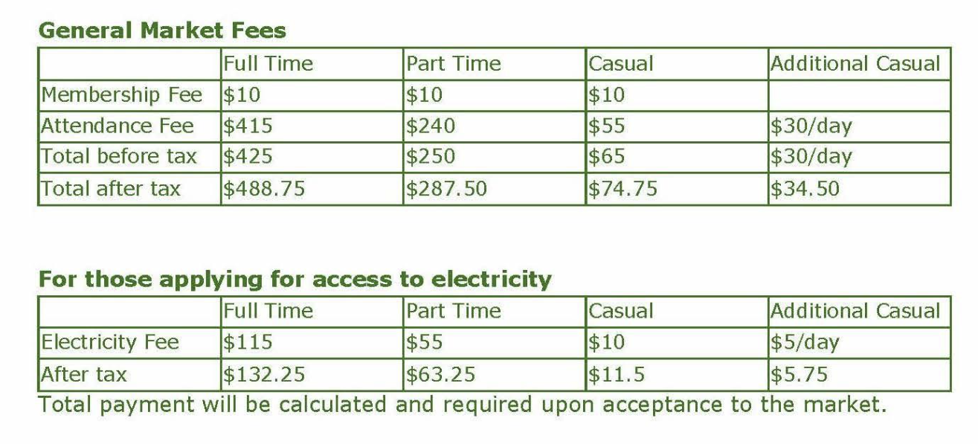

1. **Market stalls**
   1. A stall is defined as a 10 x 10 ft space
   2. Vendors are responsible for supplying their own tents and equipment. There are no restrictions on tent colour, but they must be in good repair. **All tents MUST be staked down each week to avoid damage or injury during unfavourable weather. In the absence of stakes, 30lb weights *per tent leg* will be permitted as an alternative anchor.**
   3. The market manager is responsible for assigning stalls to all vendors. Returning vendors shall have the option of returning to their same space, or being reassigned
2. **Parking and Vehicles**
   1. Vendors must remove their vehicles from the market area by 8:45 am. Vendors will park in designated vendor parking area
3. **Liability & Insurance**
   1. All vendors are required to provide their own liability insurance
   2. Marché Wakefield / Wakefield Market will not be held responsible for losses, theft, or accident or for the products or conduct of vendors
4. No smoking or vaping is allowed in the area of the market
5. The Marché Wakefield / Wakefield Market reserves the right to change the rules and regulations without prior notice. All vendors will be sent a copy of these changes

Last updated: January 2025